RFP Document Number:
Model No. | GT-E3056CV6012
P/N:
Customer:
Test Start Date: | 7 Apr 2015 | Test Completion Date: | 7 Apr 2015
Report Completion Date: | 8 Apr 2015
Test Performed by: | Lorenzo R. Madariaga II
Revision History: | Rev 01 | Initial Release
Objective: | Perform harmonic measurements using EN 61000-3-2:2006 Standard
Conclusion: | The unit passes the harmonic test as per EN 61000-3-2:2006.

Test Set-Up:
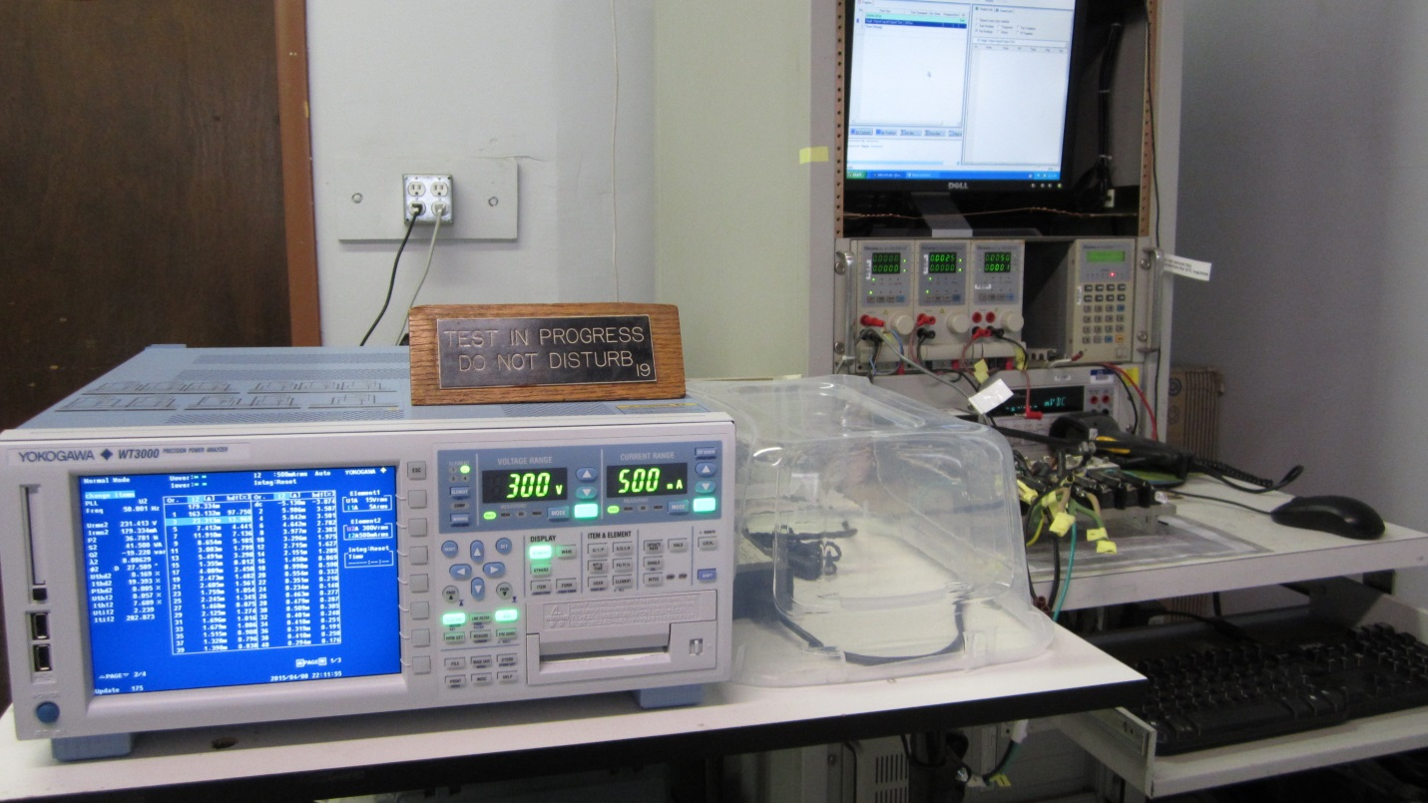

List of Equipment used:
Equipment | Manufacturer | Description
Power Analyzer | Yokogawa | WT3000 Precision Power Analyzer  Model 760302  No: 91R225637
AC Source | Chroma | Programmable AC Source  Model 61503

Current and Voltage Waveform:
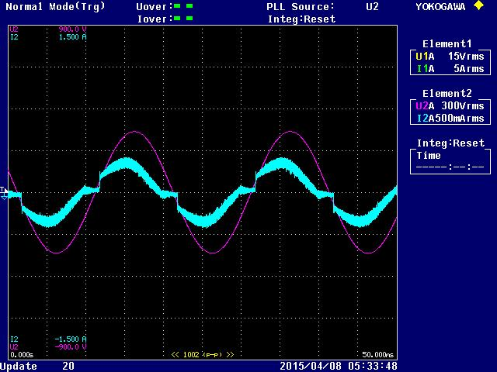

Harmonics Measurement:
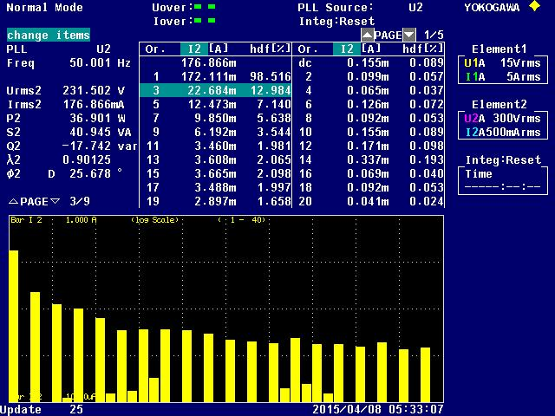
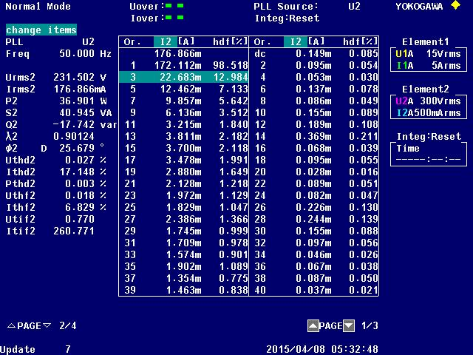

Test Measurements and Parameters:
Manufacturer Name |  | GLOBTEK, INC.
Model |  | GT-E3056CV6012
Type, P/N
Nameplate Specifications
Related Product Specifications |  | Input | Output
Voltage (V) |  | 100-240 | 12
Current (A) |  | 1.5A MAX | 5
Rated Power (Watts) |  |  | 60
Frequency (Hz) |  | 50-60
Date Measured |  | 7-Apr-15
Active Power Measurements
(30min Initial Warm-Up, 5min stability time per load condition)
Percent of Rated Load |  | 50%
DC Output Current measured (mA) (+/-2% Rated) |  | 2506.8
DC Output Voltage (V) |  | 12.3318
DC Output Power (W) |  | 30.91323
AC Input Voltage (V) |  | 230
AC Input Power (W) |  | 36.901
Total Harmonic Distortion (THD%) (1/Total) |  | 17.1480
True Power Factor(Watts/VA) |  | 0.9012
AC Input Frequency (Hz) |  | 50
Efficiency |  | 83.774%

Harmonics and Class C Limits (EN 61000-3-2:2006):

Current (mA)

Harmonic Number

Harmonics and Class C Limits (EN 61000-3-2:2006):

Harmonic  Order | Maximum permissible  Harmonic Current | Input  Current (mA) | Harmonic Limits (mA) | Measured  Fundamental Current (mA) | Status
1 |  | 176.866 | 0 | 172.112
2 | 2% | 176.866 | 3.537 | 0.095 | PASS
3 | 27.04% | 176.866 | 47.820 | 22.683 | PASS
5 | 10% | 176.866 | 17.687 | 12.462 | PASS
7 | 7% | 176.866 | 12.381 | 9.857 | PASS
9 | 5% | 176.866 | 8.843 | 6.136 | PASS
11 | 3% | 176.866 | 5.306 | 3.215 | PASS
13 | 3% | 176.866 | 5.306 | 3.811 | PASS
15 | 3% | 176.866 | 5.306 | 3.700 | PASS
17 | 3% | 176.866 | 5.306 | 3.478 | PASS
19 | 3% | 176.866 | 5.306 | 2.880 | PASS
21 | 3% | 176.866 | 5.306 | 2.128 | PASS
23 | 3% | 176.866 | 5.306 | 1.972 | PASS
25 | 3% | 176.866 | 5.306 | 1.829 | PASS
27 | 3% | 176.866 | 5.306 | 2.386 | PASS
29 | 3% | 176.866 | 5.306 | 1.745 | PASS
31 | 3% | 176.866 | 5.306 | 1.709 | PASS
33 | 3% | 176.866 | 5.306 | 1.574 | PASS
35 | 3% | 176.866 | 5.306 | 1.902 | PASS
37 | 3% | 176.866 | 5.306 | 1.354 | PASS
39 | 3% | 176.866 | 5.306 | 1.463 | PASS

Remarks/Shipment:
- The unit passes the harmonic test as per EN 61000-3-2:2006

